**Neck and shoulder right side**

**Initial Assessment**

|  |  |  |
| --- | --- | --- |
| **Presenting Symptom/Chief Complaint** | | |
| Acute neck obstruction syndrome on the right side with shoulder radiation due to wind cold. | | |
| **Main Signs and Symptoms** | | |
| Stiffness and rigidity of neck on the right side, aggravated by cold and windy weather radiated to the right shoulders. | | |
| **Other Signs and Symptoms** | | |
| Limitation of movement in the neck from side to side. Abduction of the arm (right) due to L1 channel involvement. | | |
| **TCM Diagnosis and Treatment (identified TCM disease, TCM differentiation of syndromes)** | | |
| Acute neck obstruction syndrome with radiation to the right shoulder due to wind cold invasion. LI syndrome. | | |
| **Treatment Principles and Strategies** | | |
| Remove wind; eliminate cold, with the use of peripheral points by releasing technic, than use of local joints tonification. | | |
| **Treatment Plan (Modalities; acupuncture, herbal, dietary, manual therapies), frequency and duration** | | |
| Acupuncture. LI-1(bilateral) LI-II(bilateral)- eliminate cold. GB-39(bilateral)-free link side to side movement. ST 36(right side), SI 3(right side), GB20(bilateral), DU 16 | | |
| **Any other Advice Given to Patients** | | |
| Due to wind, GB 2(bilateral) relaxation of trapezius muscle. Recommended exercise for neck started from the fourth session. Warm diet. | | |
| **Practitioner:** | **Date:** | **Signature:** |

**Neck and shoulder right side**

**Daily Charting____________________________________Patient Name**

**Date:_**

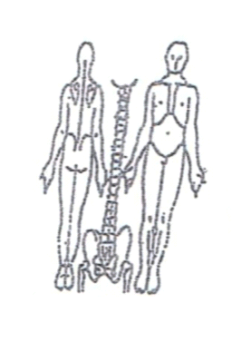 **Working Diagnosis:** Acute neck obstruction syndrome on the right side

with stiffness and shoulder radiation due to wind cold.

S: Stiffness and shoulder rigidity of the neck, pain level 3-4, ROM, side to side movement.

O:

Treatment (P) Due to wind, GB 2(bilateral) relaxation of trapezius muscle. Recommended exercise for neck started from the fourth session. Warm diet

(A) Acupuncture 1 hour. Third day with warm needles

**Date: ______________**

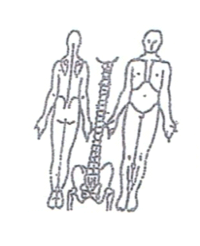**Working Diagnosis:**

S: Symptoms the same. Pain level the same. Neck stiff and rigid. Sleep better.

O:

Treatment (P) Acupuncture: according to plan-1 hour

(A)

**Date:**

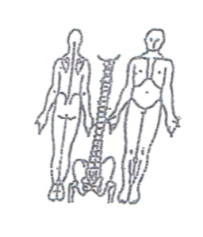**Working Diagnosis:**

S: stiffness and rigidity. ROM. Pain level the same.

O:

Treatment (P) Acupuncture: according to plan 1 hour (A)

**Date:**

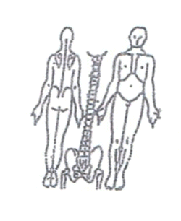

**Working Diagnosis:**

S: Normal neck movement. Still have pain in the right shoulder. Pain level 2-3. Sleep better.

O:

Treatment (P) Acupuncture + stretching exercises.

(A)

**Date:**

**Working Diagnosis:**

S: Symptoms the same. Pain level 2-3. pain in the right shoulder. ROM

O:

Treatment (P) Acupuncture + Exercises 1 hour.

(A)

**Date: Working Diagnosis:**

S: ROM-N. Sleep well. No stiffness. No rigidity.

O:

Treatment (P) Acupuncture-1 hour, warm neck band

(A)

**Date:**

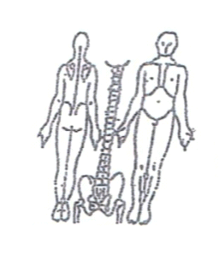**Working Diagnosis:**

S: No pain. N ROM. Sleep well.

O:

Treatment (P) Acupuncture + stretching exercises 1 hour.

(A)